1. **How to Access SVN**

**Repository URL:**  As given by instructor or Tech Lead.

**Login ID**   : As given by instructor or Tech Lead.

**Password**: As given by instructor or Tech Lead.

1. **Steps to Checkout code from the repository**

**Just Right click on the desktop**  


**Got to Tortoise SVN and Repo Browser and copy the url of the project in which u are in**

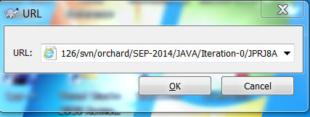 **Please note the URL which is specified   
makes sure it is https not http**

1. **Open MySQL and run the DB Script “\DB Script\mysqlwithdata-Iteration1.sql”**
2. **Open Eclipse**
3. **Select a workspace**
4. **Click on File -> Import**

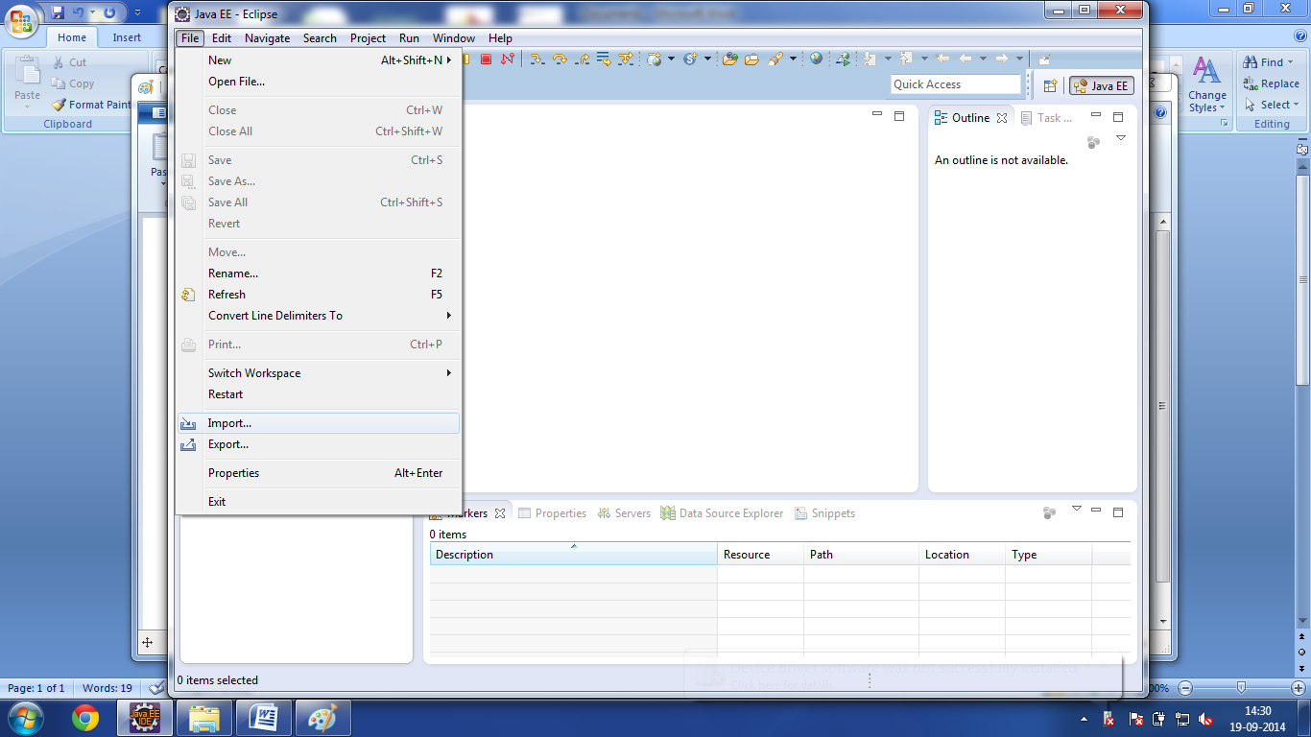

1. 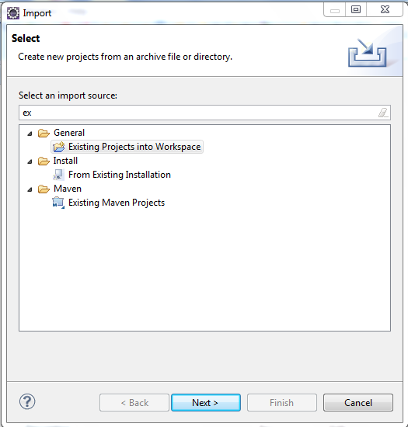**Click on existing project into workspace**
2. **Browse to the folder where you have checked out the code**

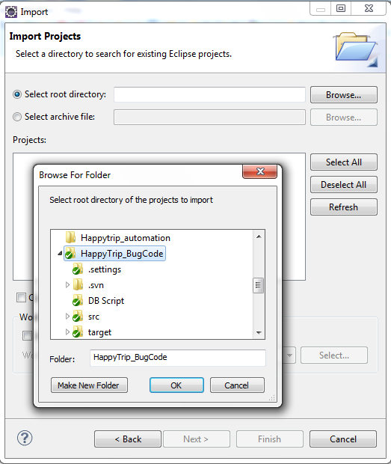

1. **Click OK -> Finish. Now it will build the workspace**

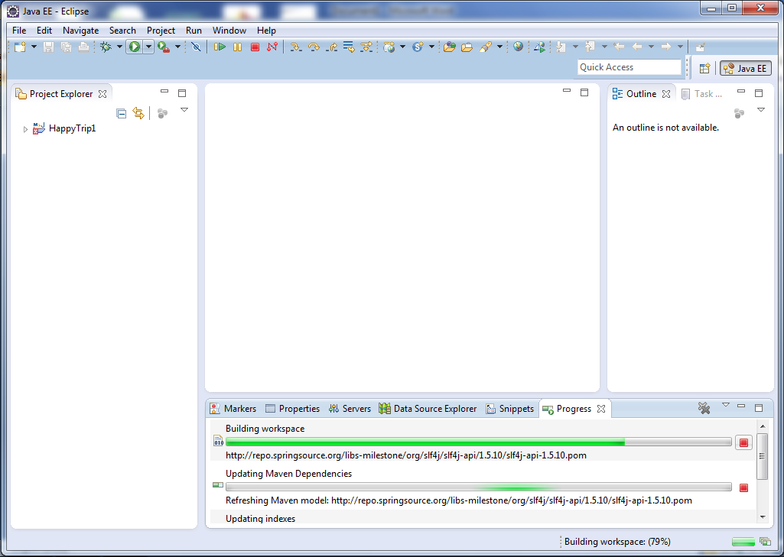

1. **Now Change the database credentials in the following file**

\src\main\resources\spring\security-context.xml

\src\main\resources\data\data.properties

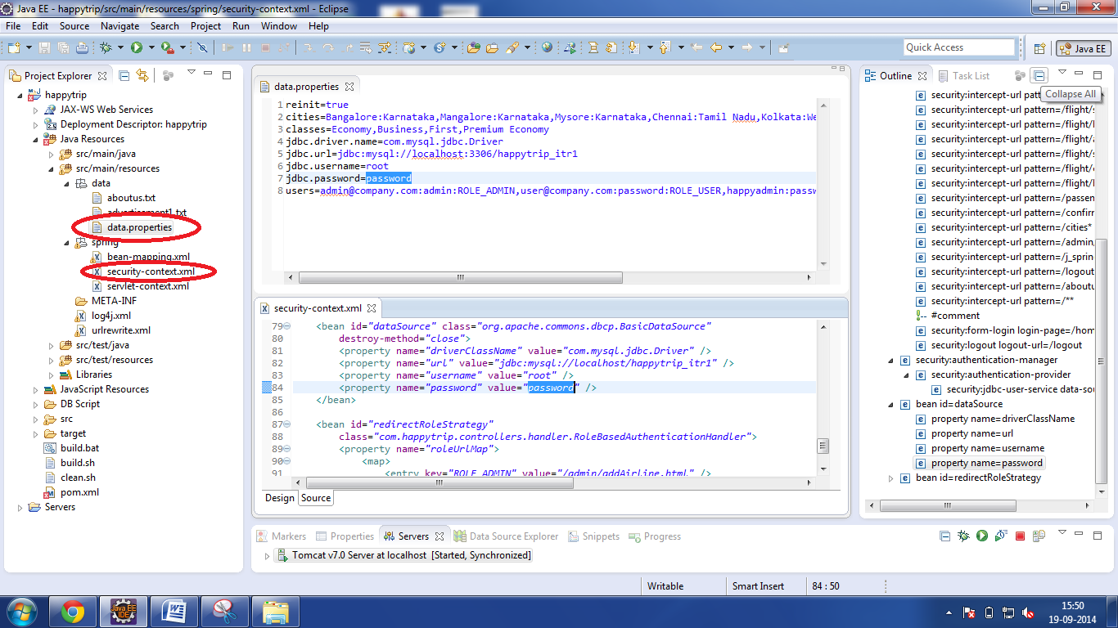

1. **You will be able to see following things in explorer**

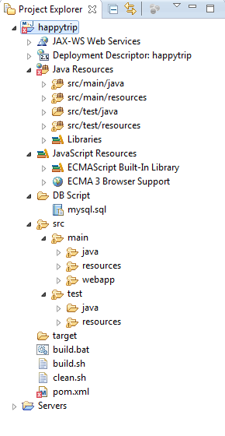

1. **Add a Server to Run HappyTrip**

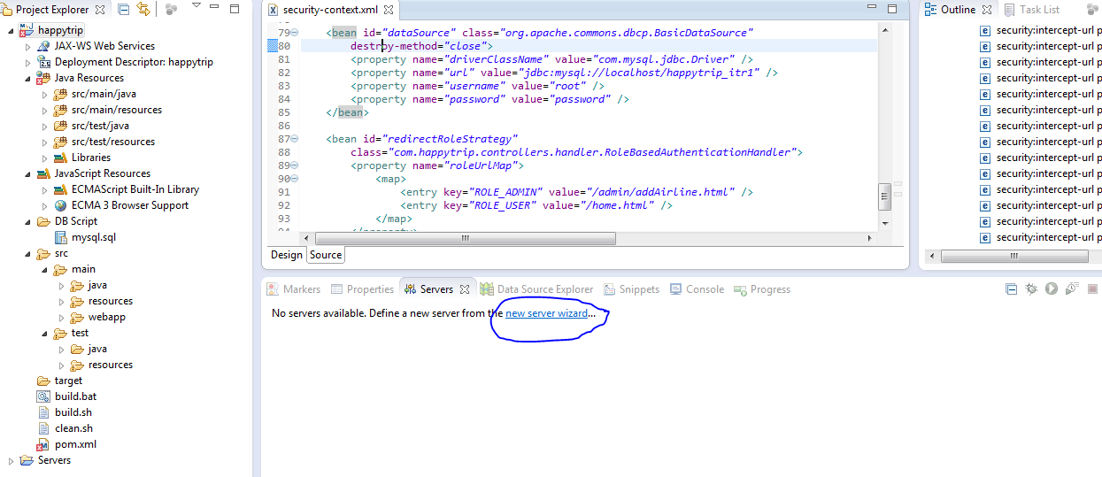

1. **Select Tomcat 7.0**

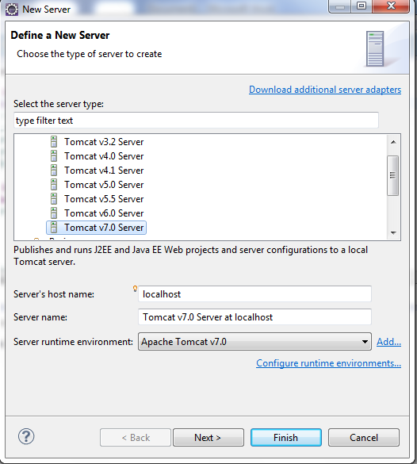

1. **Click Next, Browse to the Tomcat location**

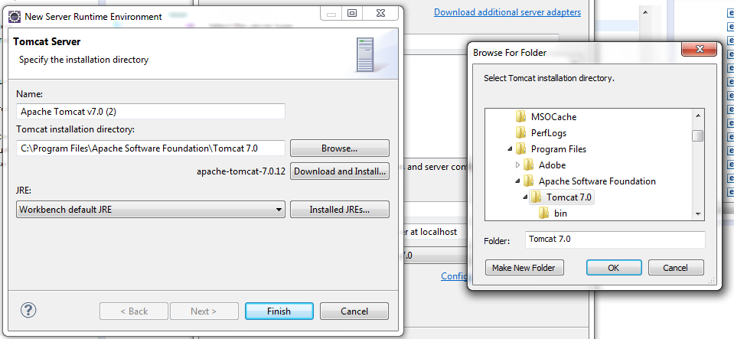

1. **Right Click on happytrip -> run as -> run on server**

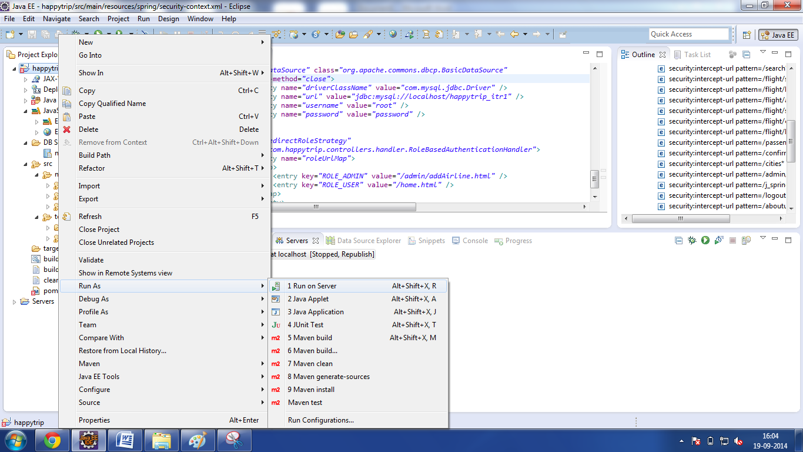

1. **Select happytrip to run on server**

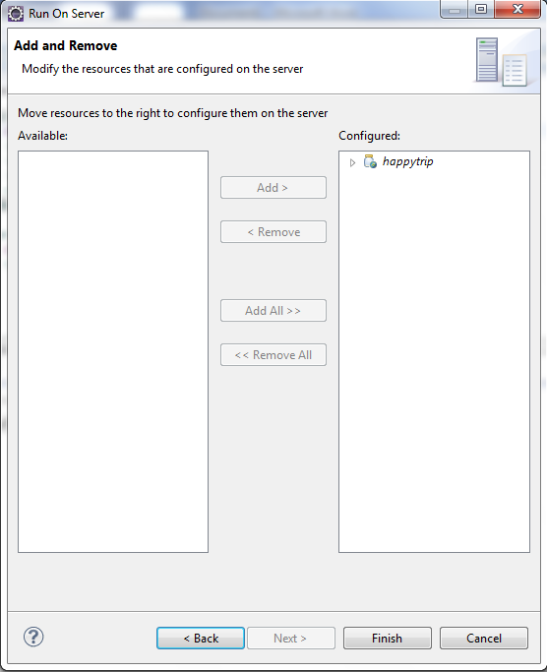

1. **Click Finish**
2. **Your HappyTrip is Up and Running**

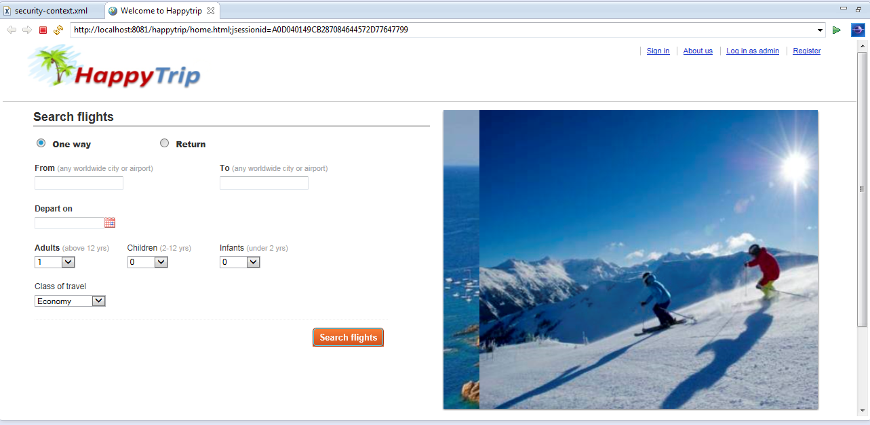

**If you are having problem**

**Right Click on happytrip -> Properties -> Java Build Path -> Source**

**Check if you have all the folders or not, if not just add it**